How to get FEDLOG access that works and is FAST!

If you have F drive access to the server mainframe do the following steps to make FEDLOG work faster and better.

1. Go to the following address in windows explorer: F:\apps\CDTower\FEDlog
2. If you do not have access to the F drive, contact me and I will burn you a DVD. Or contact the IT people and request the Drive.
3. Copy the FEDLOG folder to your desktop. Do not move. COPY ONLY!

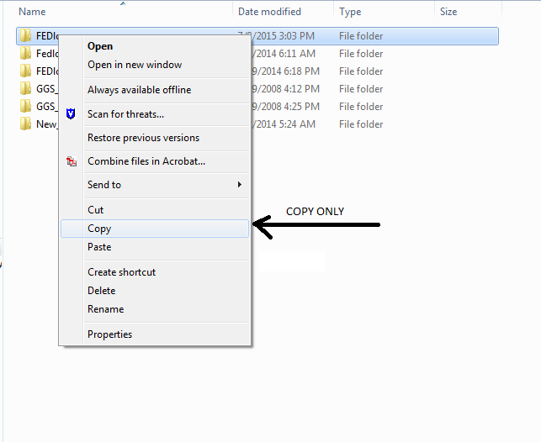

1. Once the folder is finished copying to your desktop (This can take up to 30 mins), Open the folder and find the file that says IMD.exe

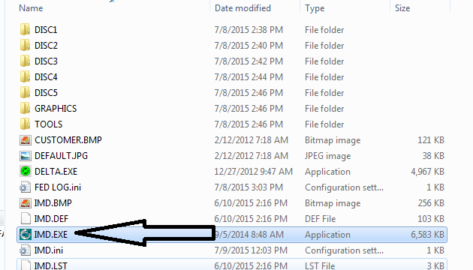

1. Copy IMD.exe to your desktop and place it next to your FEDLOG folder you just placed there. Rename the File FEDLOG C DRIVE.

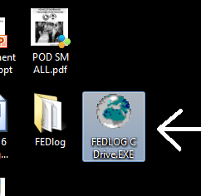

1. Double click on FEDLOG C DRIVE.exe (Open it)
2. A screen will come up asking if you want to run an executable, Hit Allow.

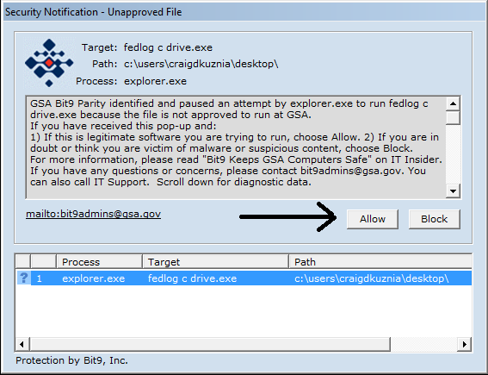

1. The FEDLOG box will open. It has no path. You have to show where you want it to look.

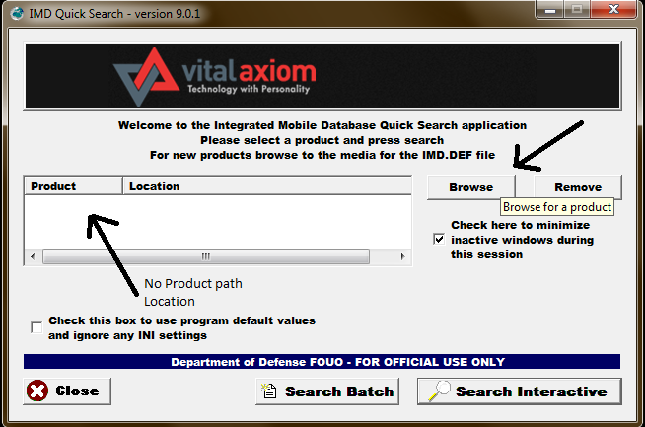

1. Click on the Browse icon button.
2. When you are browsing, look for the FEDLOG folder you just placed on the desktop.
3. In that folder, find the IMD.DEF. It is the last file after the folders.

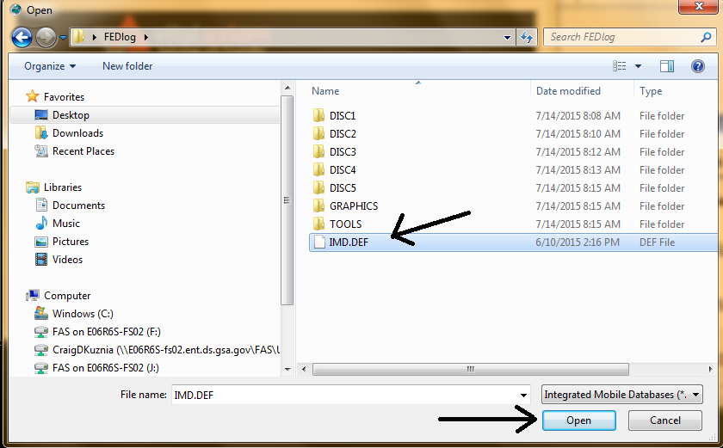

1. Click on that and hit open.

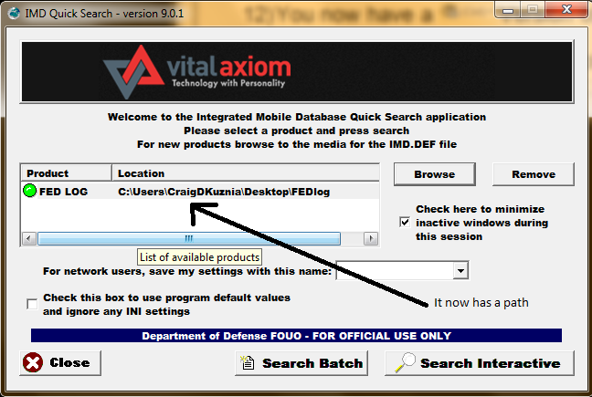

1. You now have the product and it is located properly and has a path to your C drive (Desktop path).
2. You now have a faster Version of FEDLOG that runs on your computer. Click on Search Interactive and away you go.

You will have to update the FEDLOG folder each time a new version comes out to stay up to date.